Chapter 8, Solution 59.

The switch in Fig. 8.105 has been in position 1 for t < 0. At t =0, it is moved from position 1 to the top of the capacitor at t = 0. Please note that the switch is a make before break switch, it stays in contact with position 1 until it makes contact with the top of the capacitor and then breaks the contact at position 1. Determine v(t).

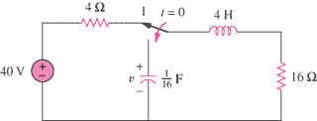

Figure 8.105
For Prob. 8.59.

Solution

Let i = inductor current and v = capacitor voltage
v(0) = 0, i(0) = 40/(4+16) = 2A
For t>0, the circuit becomes a source-free series RLC with

i(0) = 2 = A

v = –32te^{–2t} V.

Checking,
v = Ldi/dt + Ri = 4(–4e^{–2t} – 4e^{–2t} + 8e^{–2t}) + 16(2e^{–2t} – 4te^{–2t}) = –32te^{–2t} V.

